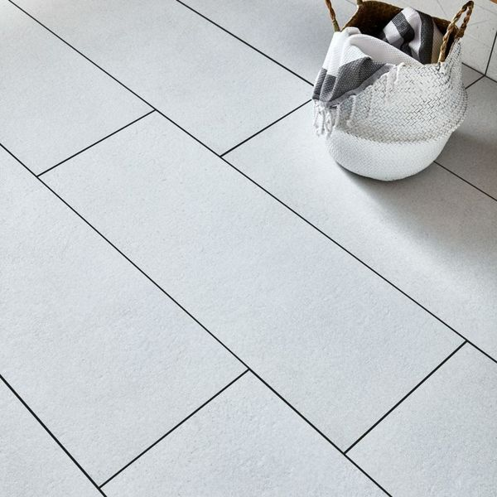**Largo Mist White Tiles:**

## **Product Description**

These XXL large-format Mist Tiles have a brushed limestone effect design with a lifelike texture. Made from porcelain, they're very durable and can be used on both walls and floors. They have a matt finish and an R10 anti-slip finish.

The idea of 'bringing the outdoors in' has never been more popular, and these tiles are perfect for creating the natural look in a bathroom, kitchen, living area, hallway or bedroom.

**What's special about these tiles?**

> Made from porcelain

> R10 anti-slip finish

> Brushed limestone effect design

> Matt finish with lifelike texture

**Take a closer look**

For a closer look, why not order a sample tile? Unlike other tile companies that only send out tiny cut samples, we send out the full-size tile so that you get the full effect. Our sample tiles come with Fast Free Delivery.

## **Product INFO**

* Product ID: 36975
* Tiles Per SQM: 3.3670033670034
* Sale by: Per SQM
* Size: 330x900x10mm
* Weight: 6.47 KG
* Material Type: Porcelain
* Finish: Matt
* Colour: White
* Suitability: Floors, Walls
* Grade: 4
* Rectified Edge: Yes
* Underfloor Heating: Yes
* Anti Slip Grade: R10 / 27-35 Degrees
* Thickness (mm): 10